**Dynamic Urban Parking Pricing Engine**

Summer Analytics 2025 - Final Submission Report

# 1. Background & Motivation

Urban parking is a limited and high-demand resource. Static pricing models often cause either underutilization (lots remain empty) or overcrowding (vehicles queuing up). To optimize utilization and improve user experience, this project implements a real-time dynamic pricing engine using basic economic theory, streaming data, and models built from scratch using only NumPy, Pandas, and Pathway.

# 2. Data Description

The dataset provided contains real-time information collected from 14 urban parking spaces over 73 days, with 18 time steps per day (every 30 minutes from 8:00 AM to 4:30 PM). Each row includes:

* Location Info: Latitude and Longitude
* Lot Features: Capacity, Occupancy, Queue Length
* Vehicle Info: Type of Vehicle (car, bike, truck)
* Environmental Info: Traffic level (low, medium, high), Special day indicator
* Time Info: Date and Time of each record

# 3. Model Descriptions

Model 1: Baseline Linear Pricing

Price[t+1] = Price[t] + alpha * (Occupancy / Capacity)

Model 2: Demand-Based Pricing

Demand = alpha*(Occupancy/Capacity) + beta*QueueLength - gamma*Traffic + delta*IsSpecialDay + epsilon*VehicleTypeWeight

Price[t] = Base * (1 + lambda * tanh(Demand)) (clipped between 0.5x and 2x base)

Model 3: Competitive Pricing (Optional)

Uses lat/long proximity and competitor prices to adjust dynamically or suggest rerouting.

# 4. Demand Function & Assumptions

Feature Mapping:

* Vehicle Type: car=1.0, bike=0.5, truck=1.5
* Traffic Level: low=0.5, medium=1.0, high=1.5
* Special Day: 0 (No), 1 (Yes)
* Normalization: tanh(Demand) for stability
* Price Limits: Min = $5, Max = $20

**5. Architecture Diagram**

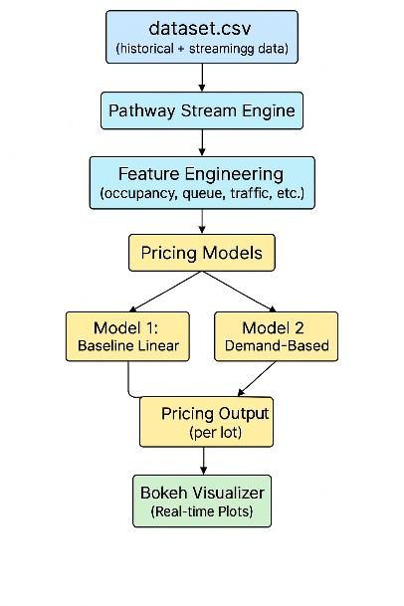

# 6. Visualization

Using Bokeh, we generated real-time line charts for each parking lot:

* Tracked Model 1 vs Model 2 pricing
* Compared prices against nearby competitors
* Updated plots in real-time in Google Colab

# 7. Conclusion

This project successfully:

* Simulated a real-time streaming environment
* Implemented three progressive pricing models
* Incorporated geographic competition and feature-based demand modeling
* Provided interactive visual validation through Bokeh

The design is modular and scalable. Future enhancements could include integration with external APIs like weather or events for better accuracy.